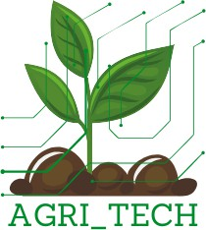
AgriTech Solutions: Innovating VET for Sustainable Agriculture AgriTech Solutions: Innovative VET for sustainable agriculture AgriTech Solutions: Innovative VET for sustainably agriculture 2024-1-RS01-KA210-VET-000244168

Teaching materials

ENVIRONMENTAL SUSTAINABILITY AND TECHNOLOGICAL ADVANCEMENT

June, 2025 year

Funded by the European Union. The views and opinions expressed are those of the author(s) and do not necessarily reflect the views of the European Union or the Education and Culture Executive Agency (EACEA). Neither the European Union nor the EACEA can be held responsible for them.


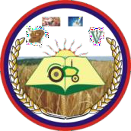
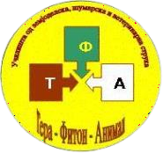


These teaching materials for Environmental Sustainability and Technological Progress were developed within the project Agrotechnological Solutions: Innovative Vocational Education for Sustainable Agriculture, Agrotechnological Solutions: Innovative Vocational Education for Sustainable Agriculture, Agrotechnological Solutions: Innovative Vocational Education for Sustainable Agriculture with grant number 2024-1-RS01-KA210-VET-000244168, funded by the Erasmus+ program of the European Union.

If you have any questions regarding teaching materials, please contact us:
Branko Rajic
Project coordinator
Association of Secondary Schools in the Field of Agriculture, Food Production and Processing
Web: https://agri-tech-solutions.com/
Email : erasmus.agritech@gmail.com​
Tel: +38137/3751-117

TEACHING MATERIALS ON ENVIRONMENTAL SUSTAINABILITY AND TECHNOLOGICAL ADVANCEMENT

Authors:

Sasha Rašković - Association of Secondary Schools in the Field of Agriculture, Food Production and Processing - Serbia
Igor Nikolov - Terra Fiton Animal High School Association - North Macedonia
Dejan Mihajlović - Association of Secondary Schools in the Field of Agriculture, Food Production and Processing - Serbia

Funded by the European Union. The views and opinions expressed are those of the author(s) and do not necessarily reflect the views of the European Union or the Education and Culture Executive Agency (EACEA). Neither the European Union nor the EACEA can be held responsible for them.

Introduction
Наставни материјали за еколошку одрживост и технолошки напредак развијени су у оквиру пројекта AgriTech Solutions: Innovativing VET for Sustainable Agriculture, AgriTech Solutions: Innovative VET for Sustainable Agriculture, AgriTech Solutions: Innovative VET for Sustainable Agriculture са бројем пројекта 2024-1-RS01-KA210-VET-000244168, који финансира Еразмус+ програм Европске уније.
This project aims to combine theoretical knowledge with practical application, thus equipping students with the necessary skills to solve modern agricultural challenges.
The main objective of this project is to improve vocational education and training (VET) in sustainable agriculture through the introduction of project-based learning (PBL), focusing on sustainable and technologically advanced agricultural practices, inclusiveness and accessibility for all learners.
The teaching materials are designed in accordance with the advanced curriculum for E- sustainability and technological progress developed within the project.
This program aims to provide students with knowledge and skills for environmental sustainability and technological progress. The curriculum integrates content from sustainable agricultural practices, precision agriculture, organic agriculture, renewable energy sources, and the use of new technologies in agriculture.
Teaching materials for Environmental Sustainability and Technological Advancement provide a comprehensive picture of the concept of sustainable development and the role of agriculture.
The approach used to develop the teaching materials is universal and applicable not only to the implementation of the advanced curriculum for environmental sustainability and technological progress, but also to all other vocational curricula implemented in secondary agricultural and veterinary schools.
We hope that the manual can also be used as a resource for teaching about sustainable development and the role of agriculture within regular professional and theoretical courses, electives, and extracurricular activities.

From the author
Contents

Introduction 3
Sustainable agriculture - the path to the future 7
- Introduction to sustainable agriculture 7
- Principles of sustainable agriculture 7
- Techniques and methods of sustainable agriculture 9
- Benefits of sustainable agriculture for the community and the environment 10
- Challenges in implementing sustainable agriculture 11
- Incorporating sustainable agriculture into the curriculum……………………………………… 12
- Zak lucak 12
Precision Agriculture - Technology, Application and Sustainable Development 14
- Historical development of precision agriculture 14
- Key technologies 15
- Applying precision agriculture in practice 17
- Advantages of precision agriculture 18
- Challenges and obstacles in implementation 18
- The role of education in the development of precision agriculture 19
- Zak Lucak 19
Organic Agriculture - Principles, Practices and Perspectives 21
- Introduction to organic farming 21
- Methods and techniques in organic production and processing 24
- Standards and certification 26
- Environmental and economic benefits 27
- Challenges and prospects 28
- Zak Lucak 29
Renewable energy sources in agriculture - an investment in the future 31
- Introduction to renewable energy sources 31
- Types of renewable energy sources and their application in agriculture 32
- The importance of renewable energy sources for agriculture 34
Modern technologies in agriculture - The path to sustainable and efficient agriculture 39
- Introduction to modern technology in agriculture 39
- Digitalization in agriculture 40
- Use of drones in agriculture 41
- Automation and robotics 42
- Precision Agriculture 42
- Sustainable Agriculture and Technologies 43
- Challenges and obstacles in the application of technology 44
- Zak Lucak 44

Sustainable agriculture - The path to the future

Sustainable agriculture - The path to the future
- Introduction to sustainable agriculture

Sustainable agriculture is a comprehensive approach to food production that seeks to meet the needs of the present generation without compromising the ability of future generations to meet their own needs.
It is a dynamic system that integrates environmental responsibility, economic profitability, and social justice.
Unlike conventional (industrial) agriculture, which often relies on the intensive use of synthetic fertilizers, pesticides, and monocultures, leading to soil degradation, water pollution, and biodiversity loss, sustainable agriculture promotes harmony with nature. It does not see the farm as an isolated factory, but as part of a wider ecosystem.

Image Training on environmental sustainability and technological progress

The goal of sustainable agriculture is not only to produce sufficient quantities of food, but also to preserve natural resources - primarily soil, water and genetic diversity - which are the basis of agricultural production itself.
It is a response to growing global challenges such as climate change, water scarcity and the need for healthy and safe food.

- Principles of sustainable agriculture

Sustainable agriculture is based on three interconnected pillars or principles:
a) Environmental sustainability (Healthy planet)
This principle focuses on preserving and improving the natural environment. The key objectives are:
  - Preserving soil fertility: reducing erosion, increasing organic matter content and improving biological activities in the soil.
  - Protection of water resources: Rational use of water for irrigation and prevention of pollution of surface and groundwater.
  - Biodiversity conservation: Creating conditions that support the survival of diverse plant and animal species in and around the farm.
  - Pollution reduction: Minimal use or complete elimination of synthetic pesticides and fertilizers.
  - Closing the loop: Recycling nutrients within the farm, for example, through the use of manure and composting.


Image Training on environmental sustainability and technological progress

b) Economic viability (profitability)
Agriculture must be economically viable to be sustainable in the long term. This principle implies:
  - Profitability for the farmer: Ensuring stable and fair incomes for producers.
  - Reducing dependence on external influences: Reducing costs through the production of your own seeds and fertilizers (compost, manure) and reduced use of pesticides .
  - Efficiency and risk management: Applying efficient production methods and crop diversification to reduce the risk of failure.
• Adding value to products: Processing of agricultural products (e.g. production of juices, jams, cheeses) and direct sales to consumers.
c) Social sustainability (fair treatment of people)
This pillar addresses the quality of life of farmers, workers and the local community. It includes:
  - Fair working conditions: Ensuring a safe and healthy working environment and fair compensation for all employees.
  - Production of healthy and safe food: Providing consumers with high-quality food, free of harmful residues.
  - Strengthening rural areas: Stimulating the local economy, preserving traditional knowledge and cultural heritage of villages.
  - Connecting producers with consumers: Building trust through short supply chain systems (selling at markets, selling from home).

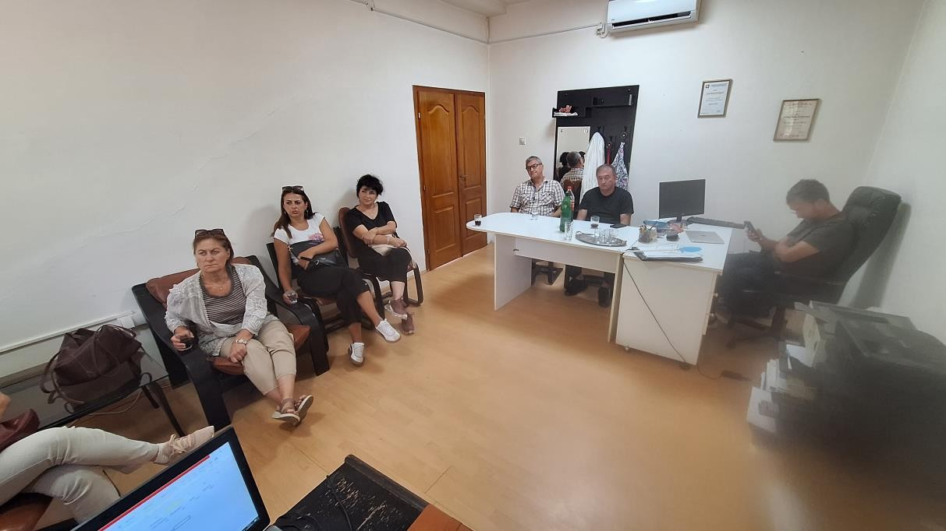
Image Training on environmental sustainability and technological progress

- Sustainable agriculture techniques and methods
There is a wide range of practical methods that farmers can apply:
- Crop rotation: The systematic alternation of different crops on the same plot of land from year to year. Crop rotation breaks disease and pest cycles, improves soil structure and fertility, and reduces the need for fertilizers.
- Conservation tillage: Techniques such as reduced tillage or direct seeding without plowing. These methods conserve soil moisture, reduce erosion and fuel consumption, and increase organic matter content.
- Integrated Pest Management (IPM): An approach that combines different methods for pest and disease control, prioritizing biological and mechanical measures over the use of chemicals. It includes monitoring pests, using natural enemies, and applying pesticides only when necessary.
- Organic production: A production system that relies on natural processes and completely excludes the use of synthetic fertilizers, pesticides, and GMOs.
- Agroforestry: The integration of trees and shrubs with crops or livestock on the same land. Trees provide protection from wind and erosion, create habitat for beneficial insects and birds, and can be a source of additional income (fruit, timber).
- Cover crops and green manure: Sowing crops (e.g. clover, fescue) not for harvest, but to protect the soil from erosion during the winter and to enrich it with organic matter and nitrogen after plowing.
- Precision agriculture: Using modern technologies (GPS, sensors, drones) for the targeted application of water, fertilizers, and plant protection products, thereby reducing consumption and negative environmental impact.
- Water management: Using drip irrigation systems, rainwater harvesting, and other techniques for efficient water use.
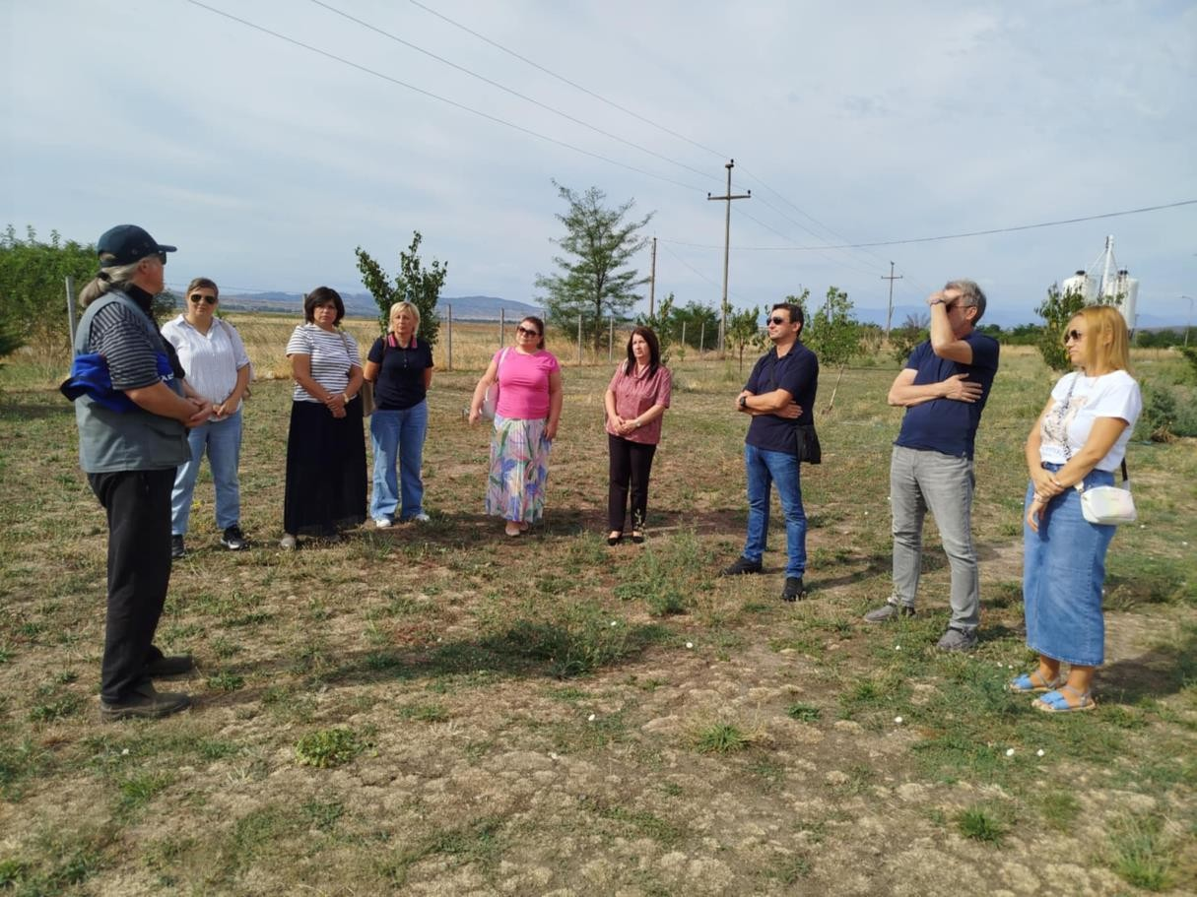
Image Training on environmental sustainability and technological progress
4. Benefits of sustainable agriculture for the community and the environment
- Environmental protection: Reduced water and soil pollution, biodiversity conservation, healthier ecosystems and greater resilience to climate change.
- Healthier and safer food: Products with fewer or no pesticide residues, which directly impacts improving public health.
- Economic revitalization of rural areas: Creation of "green" jobs, stimulation of local markets and tourism (ecotourism, rural tourism).
- Strengthening social cohesion: Building trust and strengthening connections between producers and consumers, which contributes to the stability of the local community.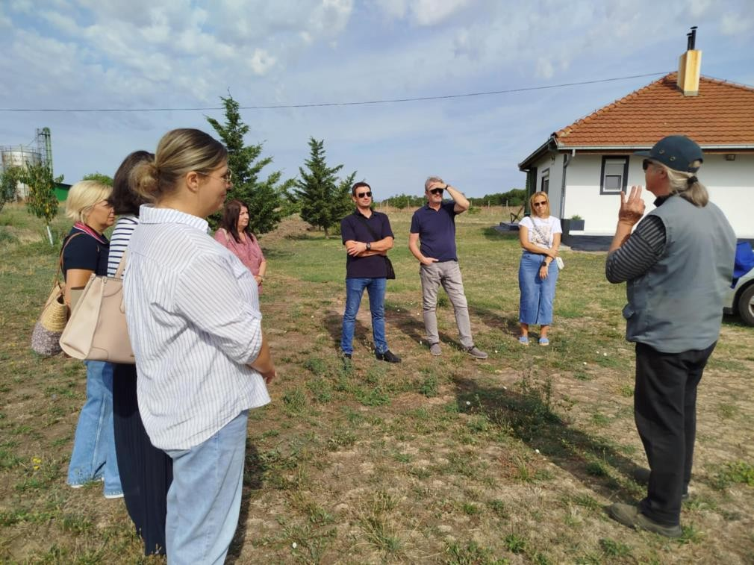
Image Training on environmental sustainability and technological progress
5. Challenges in implementing sustainable agriculture
The transition from conventional to sustainable agriculture is not always easy and carries with it certain obstacles:
- Lack of knowledge and education: Many farmers are not sufficiently familiar with sustainable farming techniques.
- Economic risk during the transition period: The transition period may bring a temporary reduction in yield until the farm ecosystem recovers and a new balance is established.
- Market access: Difficulty in finding markets and achieving higher prices for products obtained in a sustainable way.
- Lack of systemic support: Insufficient subsidies, advisory support, and policies that would stimulate the transition to sustainable practices.
- Initial investment: Some techniques may require initial investment in new equipment or infrastructure .
6. Incorporating sustainable agriculture into the curriculum and teaching programs
Education is key to the widespread adoption of sustainable agriculture. Action is needed at all levels:
  - Primary and secondary education: Introducing topics about sustainable agriculture, ecology and healthy lifestyles into subjects such as biology, geography and technical education. Organizing school gardens where children can learn about cycles in nature in a hands-on way.
  - Secondary vocational agricultural schools: Modernize curricula with a focus on sustainable techniques. Increase the number of practical classes on demonstration, sustainable farms.
  - Higher education (Faculties of Agriculture): Research work and introduction of specialized courses and master's programs dedicated to agroecology and sustainable food production systems.
  - Adult education and advisory services: Continuing education of existing farmers through workshops, seminars and advisory services that specialize in sustainable practices.
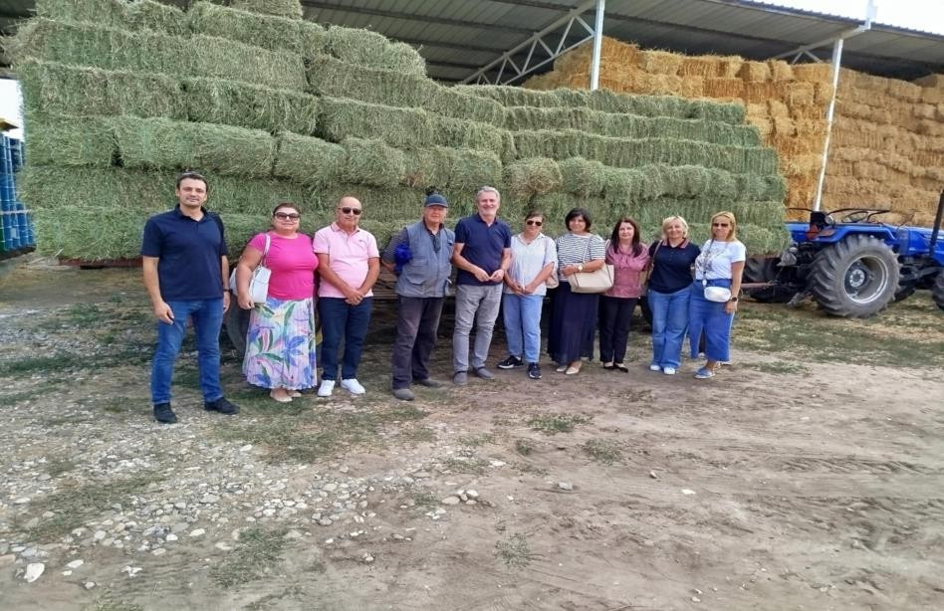

7. Conclusion
Picture Training on environmental sustainability and technological progress

Sustainable agriculture is not a return to the past, but an innovative and science-based path to the future. It offers the right solution to one of the greatest challenges of the 21st century: how to feed a growing world population while protecting the planet and its resources. Implementing sustainable agriculture requires a collaborative effort between farmers, scientists, policymakers, the education system, and consumers themselves. By embracing its principles, we can build a more resilient, equitable, and healthy food production system that will serve us and future generations. It is an investment in the health of our children, the vitality of our villages, and the long-term stability of our planet.

Precision agriculture technology, application and sustainable development

Precision agriculture - technology, application and sustainable development
- Historical development of precision agriculture
Precision agriculture is a modern approach to agricultural production. Instead of treating the entire field in the same way, precision agriculture applies specific treatments based on the needs of certain parts of the plot.
This concept originated in the late 1980s and early 1990s, primarily in the United States.
The initial impetus was the development of the Global Positioning System (GPS). The first use of GPS in agriculture allowed farmers to accurately map yields and variations in the soil.
Initially, precision agriculture focused on variable fertilizer application. Over time, the development of geographic information systems (GIS) and sensors has enabled the application of other agrotechnical measures, such as irrigation, pesticide application, and seeding.
Today, precision agriculture involves a complex system that integrates the latest technologies and is becoming the standard in modern agriculture.

Image Training on environmental sustainability and technological progress
- Key technologies
Precision agriculture relies on several key technologies that work together to enable efficient resource management.

Global Navigation Satellite Systems (GNSS) and GPS
GNSS systems, including GPS, are essential for determining the precise location of fields. They enable precise machine guidance, yield mapping, and sampling.
Automatic steering systems (autopilots) linked to GPS allow tractors and combines to navigate the field with minimal deviations, reducing overlaps and fuel consumption.

Remote sensing (sensors)
Sensors are divided into :
- Remote sensing (Remote sensing): Drones, satellites, and aircraft with specialized cameras capture images of the terrain. Based on image analysis (e.g. NDVI - Normalized Difference Vegetation Index), it is possible to detect problems such as lack of moisture, plant diseases, or nutrient deficiencies before they become visible to the naked eye .
• Tractor-mounted sensors: Sensors mounted on agricultural machinery (e.g. yield sensors, soil moisture sensors) collect real-time data during operation.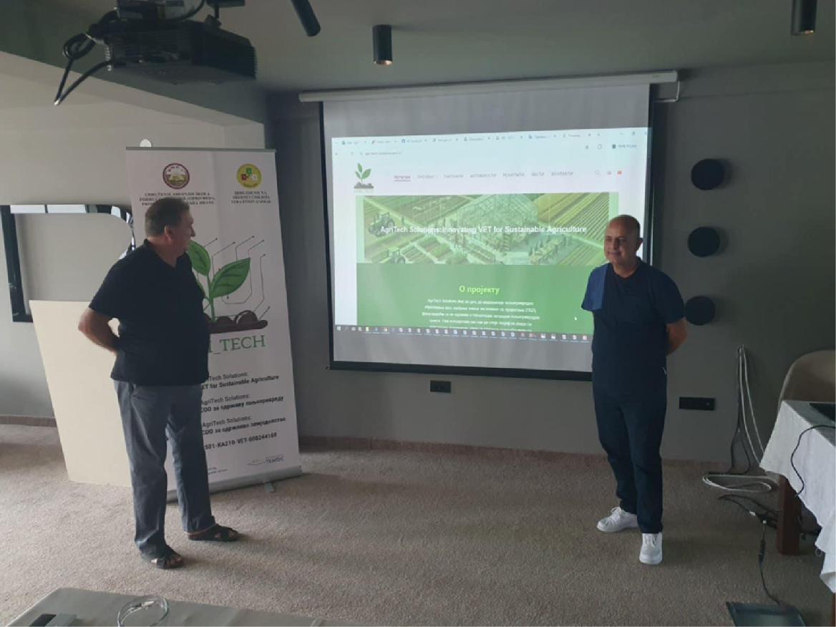
Image Training on environmental sustainability and technological progress
Geographic Information Systems (GIS)
ГИС софтвер се користи за организовање, анализу и визуелизацију ГПС и сензорских података. ГИС омогућава креирање детаљних варијабилних мапа које приказују специфичне потребе сваког дела парцеле (нпр. мапа ђубрења, мапа наводњавања).
Automation and robotics
Роботи и аутоматизовани системи, као што су аутономни трактори и комбајни, доприносе аутоматизацији процеса сетве, жетве и прскања. Ови системи раде 24/7 са високом прецизношћу.

Data collection and analysis
The foundation of precision agriculture is the efficient collection and analysis of data. It is a process that takes place in several stages:
1. Data collection: Data is collected from various sources: satellites, drones, ground sensors, weather stations, and manual soil sampling.
2. Data integration: All collected data is integrated into a single database.
3. Data Analysis: Using data analysis software, including artificial intelligence (AI) and machine learning (ML), data is analyzed to identify patterns and anomalies. Based on these analyses, recommendations for action are created.

4. Generation of variable maps: From the data analysis, maps are generated that are directly used to control machines with variable rate application (Variable Rate Technology - VRT).

Image Training on environmental sustainability and technological progress
- Applying precision agriculture in practice
Precision agriculture has wide application in various agrotechnical measures:
  - Variable fertilization: Instead of fertilizing the entire field with the same amount, fertilizer is applied at different doses depending on soil analysis and plant needs.
  - Precision sowing: Seed sowing is tailored to specific parts of the field, for example, denser sowing on fertile soil and sparser sowing on less fertile soil.
  - Weed and disease control: Drones with multispectral cameras can identify areas with weeds or diseases. Based on this information, pesticide spraying is carried out only in those areas, reducing the overall amount of chemicals.
  - Irrigation optimization: Sensors in the soil monitor moisture levels, and irrigation systems are activated only when and where needed.

Image Training on environmental sustainability and technological progress
- Advantages of precision agriculture
Precision agriculture brings significant benefits on multiple levels:
  - Environmental benefits: Reducing the use of pesticides, fertilizers and water directly contributes to sustainable development. Less pollution, preservation of soil quality and protection of biodiversity.
  - Economic benefits: Optimization of resources (seeds, fertilizers, water, fuel) leads to significant savings and cost reductions. Precise targeting of treatments increases efficiency and, consequently, increases yields and profitability.
  - Improved productivity: Automation and precision enable more efficient use of labor and reduce manual labor.
  - Better product quality: Proper plant nutrition and timely disease protection contribute to better quality and uniformity of agricultural products.

Image Training on environmental sustainability and technological progress
- Challenges and obstacles in implementation
Despite its numerous advantages, the introduction of precision agriculture faces certain challenges:
- High initial costs: Purchasing equipment (GPS, drones, sensors) and software is a significant investment for farmers.
- Lack of knowledge and skills: Managing complex technology requires training and knowledge of digital tools.
- Access to data and internet connection: In rural areas, there is often a problem with a stable internet connection, which is crucial for transferring large amounts of data.
- Equipment maintenance: Equipment requires regular maintenance and calibration, which can be an additional expense.
- The role of education in the development of precision agriculture
Education plays a key role in overcoming barriers and popularizing precision agriculture. Teachers and educational institutions must:
- Update curricula : Introduce precision agriculture modules into secondary agricultural schools and colleges
- Practical training: In addition to theoretical knowledge, practical training with modern equipment is also necessary. • Organizing seminars and workshops: holding short courses for farmers.
- Industry Collaboration : Partnering with agricultural equipment companies to provide the latest training technology.

7. Conclusion
Precision agriculture is not just a technological advancement, but also a necessary evolution in agriculture that enables sustainability, profitability, and efficiency.
Although there are challenges, investing in education and technology is key to the future of agricultural production.
Its application enables food production in a more economical and ecological way, making agriculture more resilient to climate change and economic pressures.
Precision agriculture is a bridge between tradition and innovation, ensuring that agriculture remains vital and prosperous.

Principles, practices and perspectives of organic agriculture

Organic agriculture - principles, practices and perspectives
- Introduction to organic farming
Organic agriculture is a comprehensive food production system based on the principles of ecology, health, fairness, and care.
Its primary goal is to produce high-quality, safe and nutritious food in a way that is sustainable and in harmony with nature.
This production system explicitly prohibits the use of synthetically produced pesticides, mineral fertilizers, genetically modified organisms (GMOs), as well as the use of antibiotics and growth hormones in livestock for preventive purposes.
Instead of relying on synthetic inputs, organic farming uses natural processes and resources.
She views the farm as a single, living organism in which the land, plants, animals, and people are interconnected.
The emphasis is on preventive measures, strengthening the natural resistance of plants and animals, and closing the cycles of matter within the farm itself. Organic production is not only a technique, but also a philosophy that promotes long-term soil fertility, biodiversity conservation, and animal welfare as the basis for healthy food and a healthy planet.
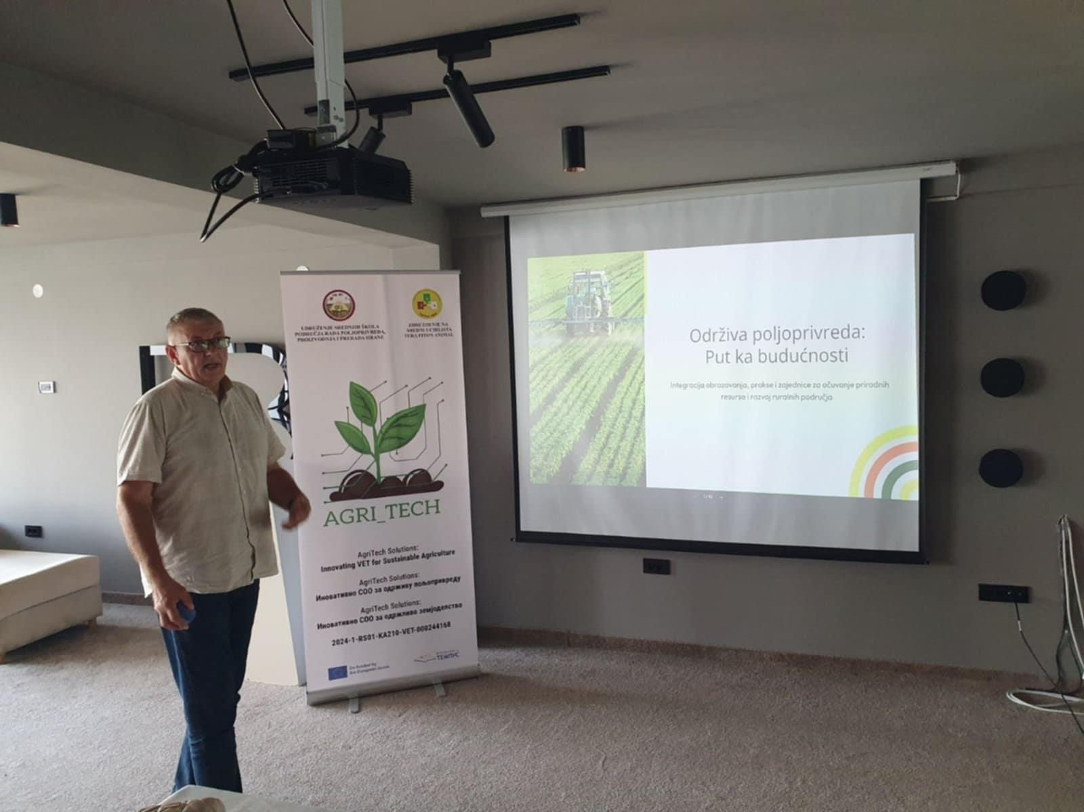
Image Training on environmental sustainability and technological progress
- Historical development of organic agriculture
Although agriculture has been practiced for thousands of years according to principles similar to today's organic production, the modern organic movement emerged in the early 20th century as a reaction to the industrialization and chemicalization of agriculture.
  - Beginnings (1920-1940) : Key figures such as Sir Albert Howard in the UK, who studied traditional Indian composting methods, and Rudolf Steiner in Germany, the founder of biodynamic agriculture, laid the foundations of the movement. They warned about the dangers of artificial fertilizers and advocated for a holistic approach to soil health.
  - Spread of the movement (1940–1970): The term "organic farming" was first used by Lord Northbourne in 1940. In the United States, J. I. Rodale popularized organic methods. During this period, public awareness of the harmful effects of pesticides grew, especially after the publication of Rachel Carson's book Silent Spring (1962).
  - Standardization and formalization (1970-present ): The first associations and certification organizations were established. IFOAM (International Federation of Organic Agriculture Movements) was founded in 1972 to unify and standardize the movement on a global scale. During the 1990s and 2000s, countries around the world enacted laws and regulations governing organic production, certification, and product labeling, making it an officially recognized and regulated production system.
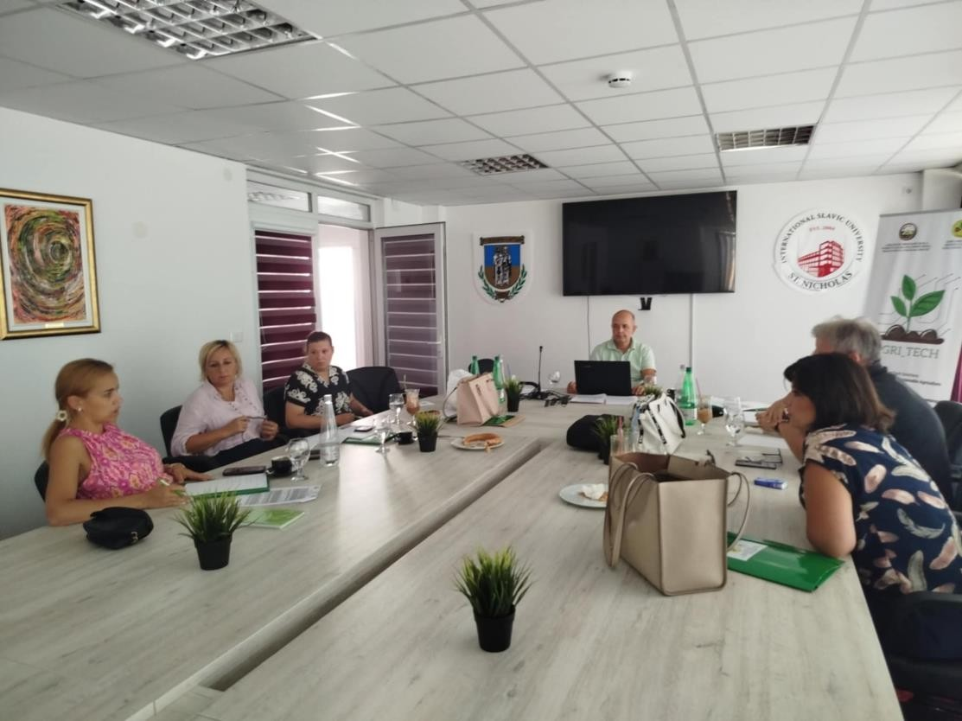
Image Training on environmental sustainability and technological progress
3. Basic principles of organic farming
According to IFOAM (the world umbrella organization for organic production - Switzerland), organic agriculture is based on four basic principles:

- The principle of health: Organic agriculture should maintain and improve the health of soil, plants, animals, people and the planet as a single and indivisible whole. Healthy soil produces healthy crops, which contribute to the health of animals and people.
- The principle of ecology: Organic agriculture should be based on living ecological systems and cycles, work with them, imitate them and help maintain them. Production must be adapted to local conditions, recycle materials and conserve energy and natural resources.
- Principle of Justice: Organic agriculture should build relationships that ensure fairness in terms of the shared environment and livelihood opportunities. It refers to fair conditions for farmers and workers, humane treatment of animals, and the provision of quality food for all, promoting social and economic justice.
- Precautionary Principle: Organic agriculture should be managed in a careful and responsible manner to protect the health and well-being of current and future generations and the environment. This means that new technologies are evaluated with caution and that unpredictable risks, such as those posed by GMOs, are avoided.
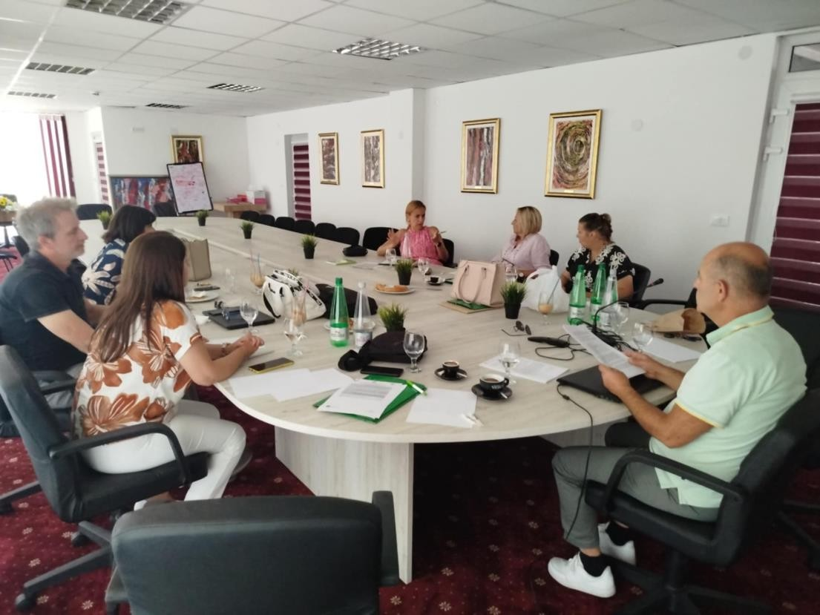
Image Training on environmental sustainability and technological progress

4. Methods and techniques in organic production and processing
a) Organic crop production
Soil fertility: The basis of organic production is living and fertile soil. Instead of synthetic fertilizers, the following are used:
- Manure - Composted or fermented manure from organic farms.
• Compost: Decomposed plant debris.
• Green manure (sideration): Plowing crops (e.g. clover, vetch) that enrich the soil with nitrogen and organic matter.

Crop rotation (crop rotation ) : A mandatory measure that involves alternating the cultivation of different plant species on a plot. Crop rotation prevents soil depletion and interrupts the development cycles of diseases and pests.
Soil treatment: A conservative treatment is applied that preserves soil structure and moisture and prevents erosion.
Plant protection : It is based on prevention. Instead of synthetic pesticides, the following are used:
• Biological control: Use of natural enemies (ladybugs, wasps) to control pest.
• Herbal preparations: Macerates and teas from nettle, garlic, horsetail.
• Mechanical measures: Collecting insects, setting traps for hunting, using protective nets.
• Selection of resistant varieties: Use of old, indigenous and resistant varieties.
Seeds and planting material: Must be produced using organic methods.
Image Training on environmental sustainability and technological progress
b) Organic animal production (livestock)
Animal welfare: This is a key element. Animals must be provided with:
• Enough space to move and express natural behavior.
• Access to open space and grazing.
• Quality mat and appropriate conditions.
Nutrition: Animals are fed 100% organically produced food, preferably from their own farm.
Health care: The emphasis is on disease prevention through strengthening immunity, quality nutrition and good housing conditions. The use of antibiotics is strictly limited to the treatment of sick animals, with a prescribed withdrawal period. Hormones and growth regulators are prohibited.

Reproduction: Natural methods are preferred.

Animal origin: Animals must come from organic farms.
c ) Processing of organic products
Maintaining integrity: The goal of processing is to preserve the nutritional value and authenticity of the raw material.
Limited use of additives: Only a small number of additives and excipients of natural origin are permitted, which are strictly listed in the regulations.
Prohibition of certain technologies: The use of ionizing radiation and genetically modified ingredients is prohibited.
Production separation: Organic products must be processed separately in time or space from conventional products to prevent contamination .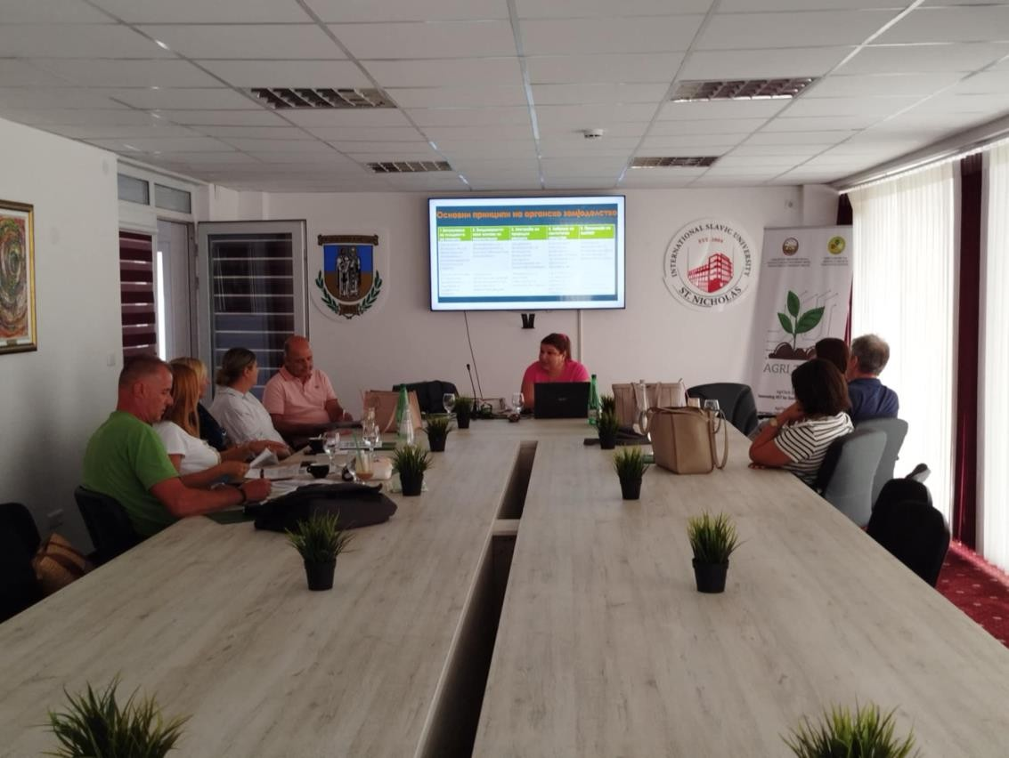
Image Training on environmental sustainability and technological progress

5. Standards and certification
In order for a product to be sold as "organic," it must go through a rigorous inspection and certification process.
Certification process:
1. Application: The manufacturer submits a request to the authorized testing agency (certification).
2. Conversion period: The producer enters a transition period (usually 2-3 years), during which he applies all organic methods, but cannot yet sell products as organic.
3. Professional control: Controllers inspect the entire farm (plots, buildings, animals, documentation) at least once a year.
4. Issuance of a certificate: If all requirements prescribed by law and standards are met, the producer receives a certificate confirming the organic status of his products. The certificate is valid for one year.
Labeling: Certified organic products must be marked with a national label and/or the EU label (green card with stars), as well as the code of the authorized control organization. The label guarantees the consumer that the product was produced in accordance with the regulations.
Legislation: Organic production is regulated by the Law on Organic Production and accompanying regulations, which are largely aligned with European Union regulations.
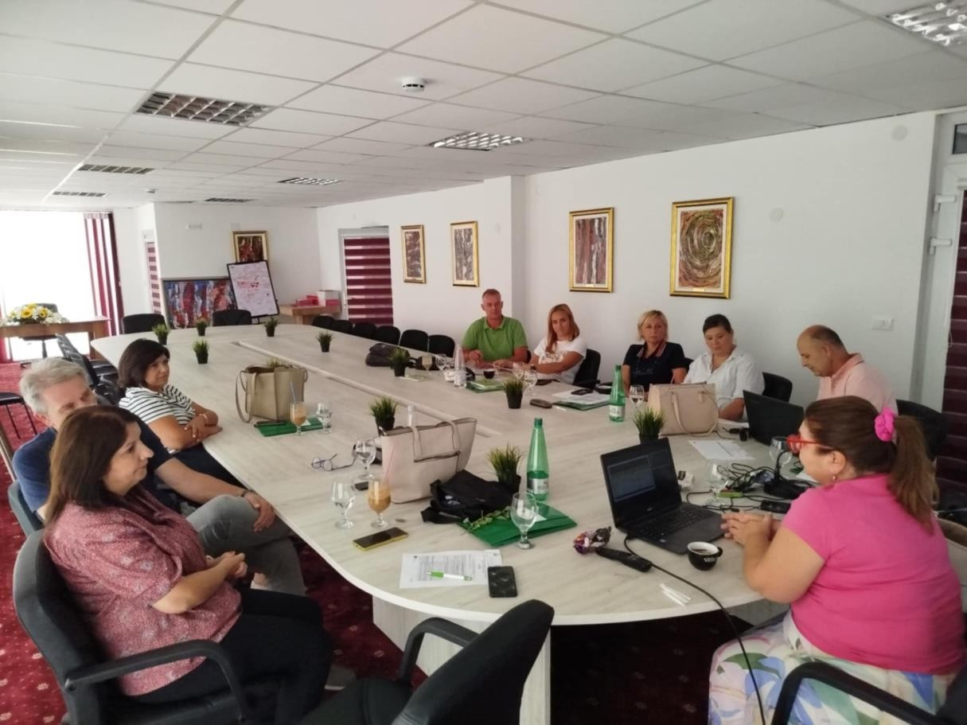
Image Training on environmental sustainability and technological progress

6. Environmental and economic benefits
Environmental benefits:
- Increasing soil fertility: Increasing humus content and biological activity.
- Preserving biodiversity: Organic farms provide habitat for a greater number of species of birds, insects, and plants.
- Water protection: Prevents pollution of groundwater and surface water with nitrates and pesticides.
- Climate change mitigation: Healthy soil rich in humus stores more carbon, reducing the amount of CO2 in the atmosphere.

• Energy savings: Organic production generally uses less energy because energy-intensive synthetic fertilizers are not used.
Economic benefits:
• Higher product price: Organic products usually achieve a higher market price (20-100% more than conventional products).
• Access to new markets: Growing demand for organic products at home and abroad opens up new sales opportunities.
- Government subsidies: The government often provides financial support to producers in organic production.
- Cost reduction: Costs are reduced in the long run because there is no purchase of expensive synthetic fertilizers and pesticides.
- Rural tourism development: Organic farms are attractive to visitors, which opens up opportunities for additional income.
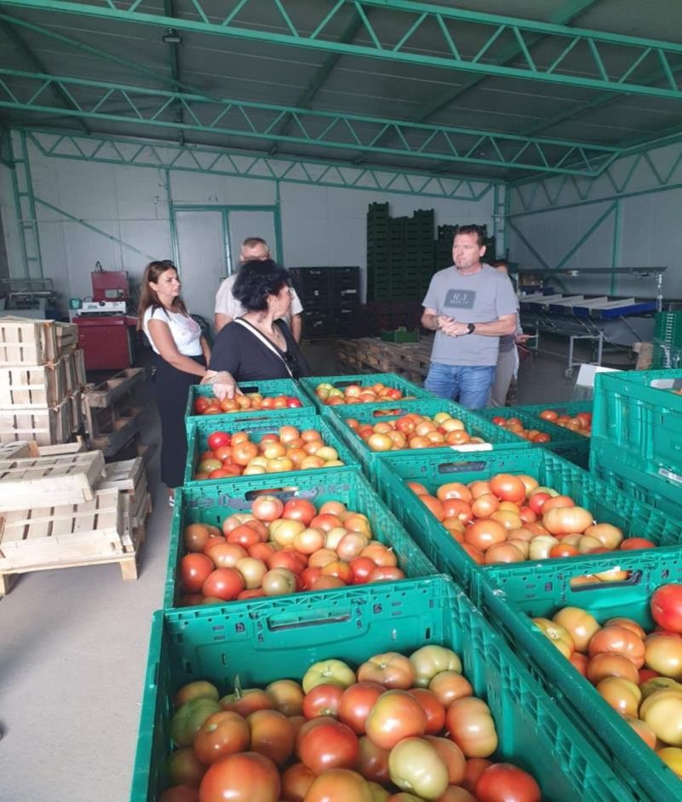
Image Training on environmental sustainability and technological progress

7. Challenges and prospects
Challenges:
- Lower yields: Especially in the initial years, yields may be lower compared to conventional production.
- Slower production: Requires more knowledge, skills, and manual labor (e.g., in weed control).
- Disease and pest risk: Good knowledge of preventive measures is required, as intervention options are limited.
- Complex certification: The certification process can be administratively and financially burdensome for small producers.

• Fragmented market: Underdeveloped supply and distribution chains.

Prospects:
- Growing consumer awareness: More and more people are looking for healthy, safe and ecologically produced food.
- Climate change: Organic agriculture, due to its resilience, offers solutions for adapting to changing climate conditions.
- New technologies: Innovations in biological protection, mechanization, and precision agriculture can facilitate organic production.
- Public policy support: Organic agriculture is recognized as a key element of sustainable development in the strategies of many countries.
- Global trend: The organic market is experiencing steady growth globally, which represents an excellent export opportunity.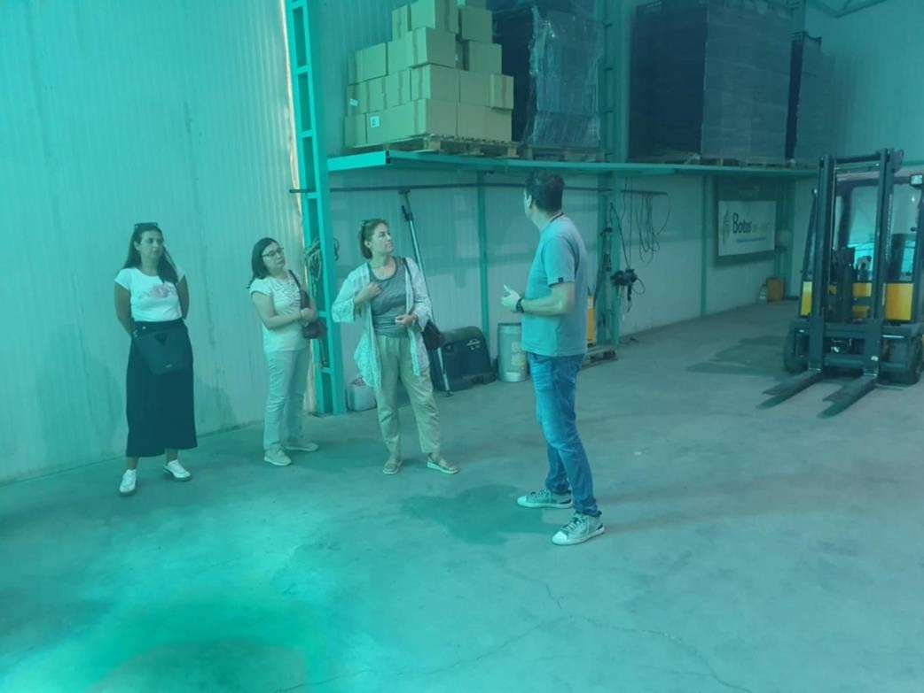
Image Training on environmental sustainability and technological progress

8. Zak lucak
Organic farming is much more than a chemical-free farming technique; it is a proactive and innovative approach that integrates scientific knowledge and traditional practices to create a resilient, productive and equitable food system.
Although it faces certain challenges, its environmental and economic benefits, coupled with growing market demand, make it one of the most promising directions for the future of agriculture.
Investing in organic production is a direct investment in human health, environmental protection, and the sustainable development of rural areas.

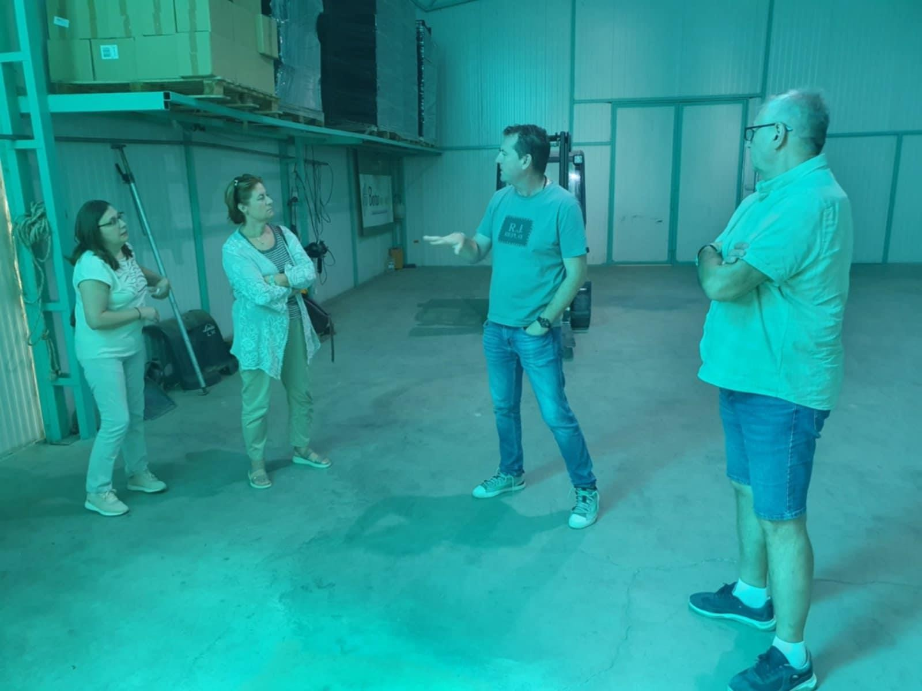
Image Training on environmental sustainability and technological progress

Renewable energy sources in agriculture
Investing in the future

Renewable energy sources in agriculture - an investment in the future
- Introduction to renewable energy sources
Renewable energy sources (RES) are energy sources that are obtained from natural processes that are constantly renewed. Unlike fossil fuels (coal, oil, natural gas), whose reserves are limited and their combustion has significant negative consequences for the environment, RES are sustainable and more environmentally friendly. The main characteristics of renewable energy sources are:
  - Durability : They can be used indefinitely without the risk of exhaustion.
  - Reduced greenhouse gas emissions: Renewable energy production generally has a significantly lower carbon footprint, thereby contributing to the reduction of climate change.
• Energy independence: Dependence on fossil fuel imports is decreasing, which increases energy security at the local and national level.
• Diversification of energy sources: Enables the creation of a higher quality and more resilient energy system.
Switching to renewable energy sources is not only an environmental imperative, but also an economic opportunity. In agriculture, a sector that is both a large energy consumer and vulnerable to the impacts of climate change, the integration of RES brings multiple benefits, from reducing production costs to creating new sources of income.


Image Training on environmental sustainability and technological progress
- Types of renewable energy sources and their application in agriculture

Agricultural farms are ideal places for implementing various technologies for using renewable energy sources due to the availability of space and biological resources.

a) Solar energy
Solar energy can be used in two basic ways:
- Photovoltaic (solar) panels that directly convert sunlight into electrical energy.
Application in agriculture:
- Powering the irrigation system (solar pumps).
- Providing electricity for farms, barns, greenhouses and glasshouses (lighting, ventilation, cooling).
- Management of electric fences and animal tracking systems.
- Charging batteries for agricultural machinery and drones.
- Solar collectors (thermal systems) that use solar energy to heat water
Application in agriculture:
  - Heating water for farm sanitary needs.
  - Preparation of hot water for washing and disinfecting equipment in livestock farming (e.g. in dairies).
  - Assistance with drying agricultural products (fruits, vegetables, medicinal herbs)
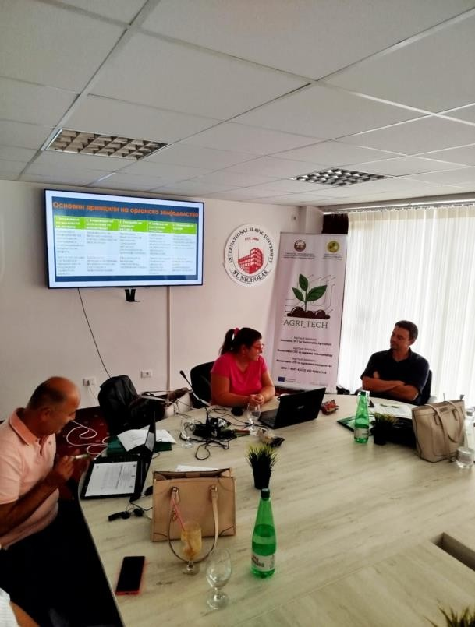
Image Training on environmental sustainability and technological progress

b) Biomass energy

Biomass is organic material of plant and animal origin that can be used to produce energy (heat and electricity) or biofuels.
Sources of biomass in agriculture: harvest residues (straw, corn cobs), fruit and grape pruning residues, livestock waste, energy crops (e.g. miscanthus).
Technologies and applications:
  - Combustion: Using biomass boilers to heat residential buildings, farms, greenhouses, and dryers.
  - Anaerobic digestion (biogas plants): The decomposition of manure and other organic matter in the absence of oxygen, resulting in biogas (used to produce electricity and heat) and digestate (a high-quality organic fertilizer).
  - Biofuel production: Processing of oil (sunflower, castor) for biodiesel or grain for bioethanol.
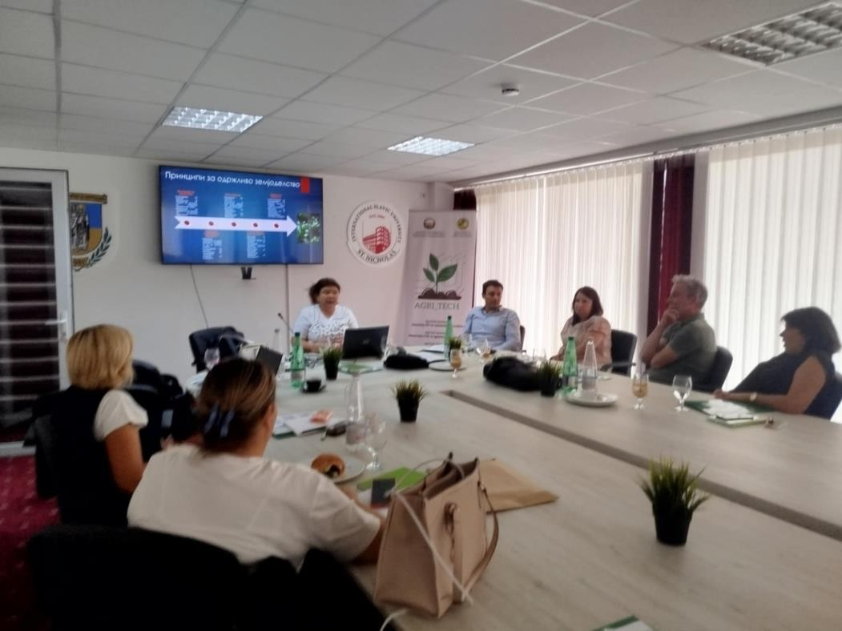
  - Image Training on environmental sustainability and technological progress
c) Wind energy
Using the kinetic energy of the wind to produce electricity using a wind turbine.
Application in agriculture:
• Small windmills: Ideal for remote farms that are not connected to the electricity grid. They can provide energy for basic needs such as pumping water, lighting and running small household appliances.
  - Large wind farms: Can be located on lower quality agricultural land, with landowners generating additional rental income while land cultivation can continue uninterrupted around the turbine foundations.
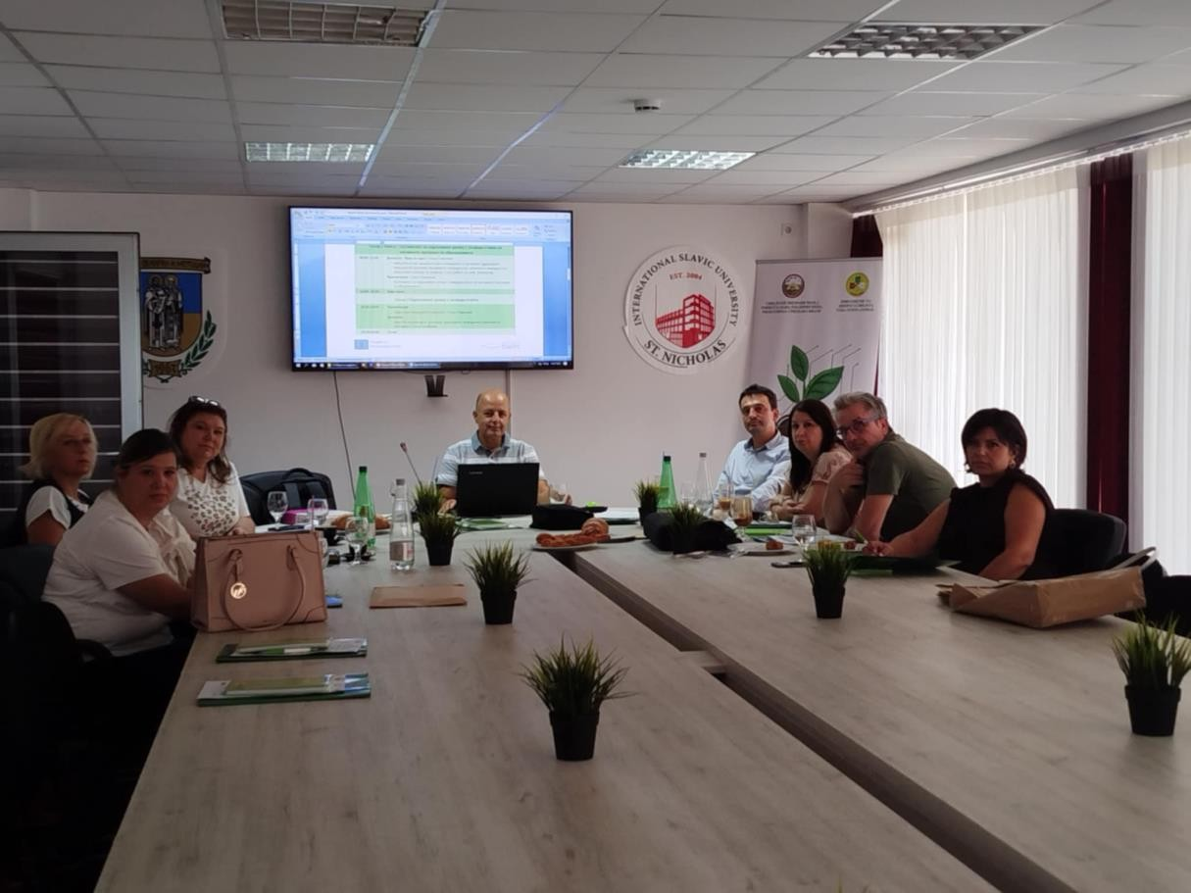
Image Training on environmental sustainability and technological progress

d ) Geothermal energy
Using heat from the Earth's interior.
Application in agriculture:
  - Greenhouse heating: Allows for the production of vegetables and flowers throughout the year with significant savings on fossil fuels.
  - Heating farm buildings: Can be used to heat barns, fish farming (aquaculture) facilities and dryers.
  - Cooling: Geothermal heat pumps can also be used to cool buildings during the summer.
- The importance of renewable energy sources for agriculture
The integration of RES into agriculture brings numerous and far-reaching benefits. Economic importance:
• Reduced operating costs: Electricity and fuel bills are reduced, which directly increases the profitability of the farm.

  - Energy independence and stability: By producing their own energy, farmers become less vulnerable to fluctuations in energy prices on the market.
  - New sources of income: Possibility of selling excess electricity generated to the grid or selling biomass. Renting land for wind farms is also a stable income.
  - Increase in property values: Households equipped with renewable energy systems become more valuable and competitive in the world.
Ecological meaning:
  - Reducing greenhouse gas emissions: Reducing the use of fossil fuels directly contributes to reducing CO2 emissions and other pollutants.
  - Sustainable waste management: Using manure and crop residues for biogas and energy production
Social importance:
- Rural development: Investments in renewable energy sources create new jobs in rural areas (installation, maintenance, facility management).
- Improving the quality of life: Reducing air and water pollution contributes to a healthier living environment.
- Awareness raising and education: Farmers who implement RES become examples of good practice and promoters of sustainable development in their communities.
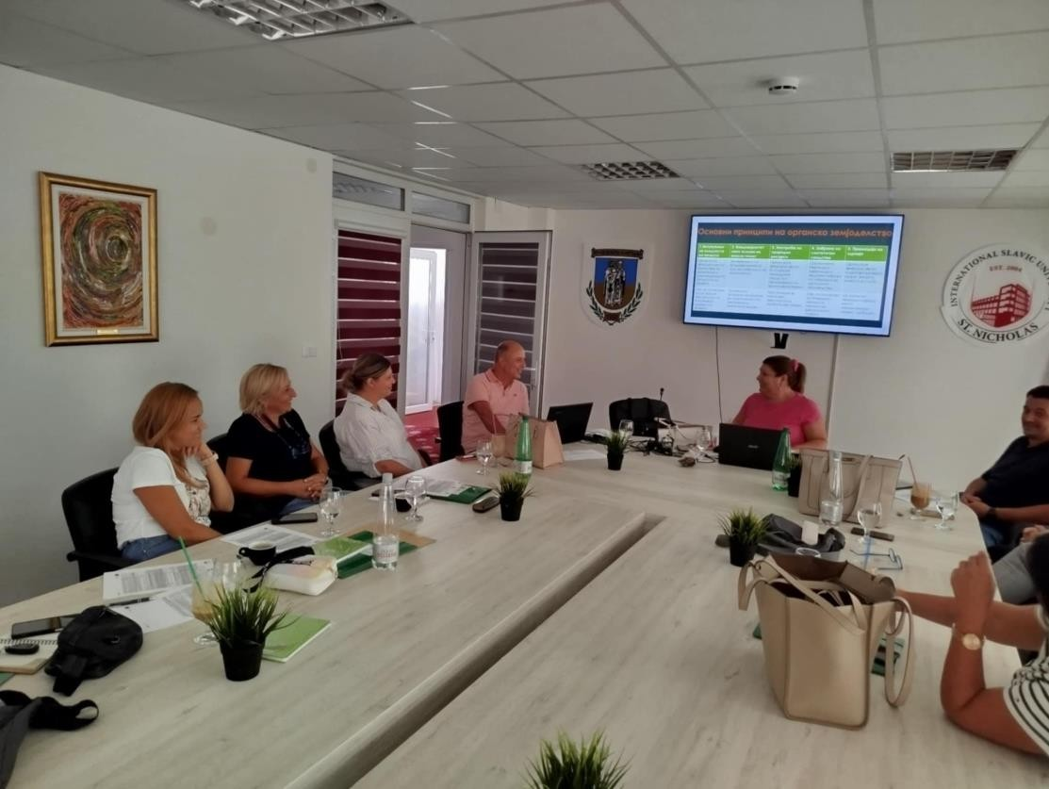
Image Training on environmental sustainability and technological progress
1. Methodologies and tools for teacher education on the integration of green energy into the education system
In order for future generations of farmers and citizens to be aware of the importance of green energy, education is key. Teachers are the bearers of this process, so their education is of crucial importance.
Teacher education methodologies:
- Professional seminars and accredited training programs:
  - Organizing one-day or multi-day seminars (in vivo and online) focused on the basics of RES, their application in agriculture and teaching methodology on the topic.
  - Topics may include: "How does a solar panel work?", "From waste to energy," "The economics and ecology of wind farms"
  - These programs should be accredited by competent educational institutions so that teachers can receive credits for professional development.
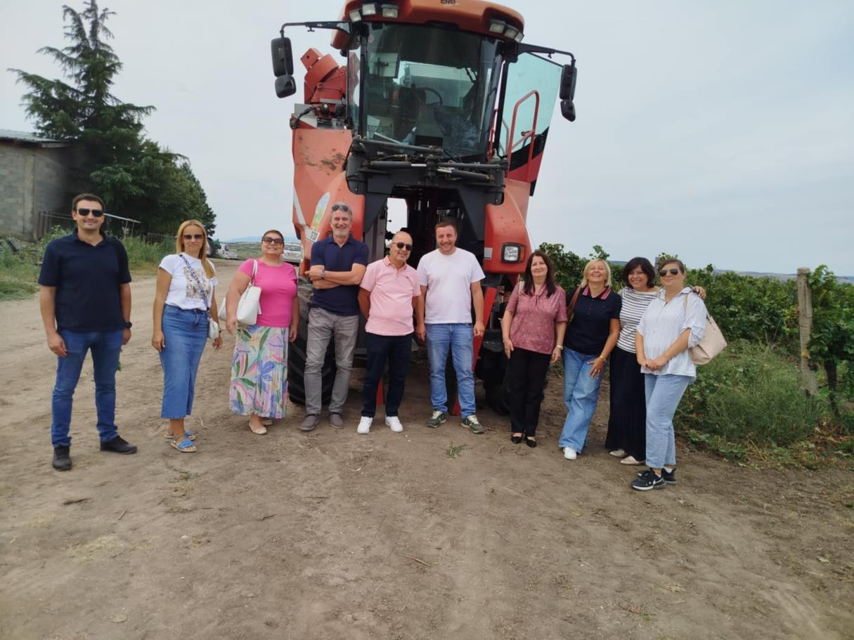
Image Training on environmental sustainability and technological progress
2. Study visits and practical workshops:
• Organizing visits to farms and companies that successfully use renewable energy sources (e.g. a visit to a farm with a solar pump, a biogas installation or a greenhouse with geothermal heating).
- Practical DIY workshops where teachers can assemble a small solar system, make a solar collector from simple materials, or a mini model windmill.

3. Networks for learning and exchange of experiences:
- Creating online platforms or organizing regular meetings where teachers can share experiences, lesson ideas, teaching materials, and challenges they face.
- Mentoring – connecting more experienced teachers with those who are just beginning to integrate these topics.
4. Project-based learning and interdisciplinary approach:
- Training teachers on how to integrate green energy topics into various subjects – physics (principles of operation), chemistry (biochemical processes in biogas), biology (impact on ecosystems), mathematics (cost-effectiveness calculations), sociology (social impact) and of course, professional subjects in agronomy.
- Support for school projects on RES (e.g. "Solar dryer in our school", "Cartography of biomass potential in our region").
Tools for education in :
  - Digital educational resources:
- Online courses and webinars: Available on demand, they allow teachers to learn at their own pace.
  - Interactive simulations and applications: Tools that enable virtual design and analysis of RES systems (e.g. solar energy calculators, biogas plant operation simulations).
  - Knowledge Bases: Digital libraries with manuals, videos, case studies, and ready-made lesson plans.
- Practical educational kits:
  - Experiment kits that allow students (and teachers) to explore RES concepts in a hands-on way. For example: a small photovoltaic panel with a light bulb and motor, a solar-powered water electrolysis demonstration kit, a mini biogas digester. 3. Teacher manuals and guides: o Printed and digital materials with specific instructions for implementing lessons, ideas for discussion, worksheets for students, and assessment suggestions. 4. Collaboration with industry and local community: o Establish partnerships with companies in the RES sector, agricultural cooperatives, businesses and local governments. Experts from these fields can be guest lecturers, and their facilities can be places for practical teaching.

Modern technologies in agriculture
The path to sustainable and efficient agriculture

Modern technologies in agriculture - The path to sustainable and efficient agriculture

1. Introduction to modern technology in agriculture
Agriculture, one of the oldest human activities, is entering a new, technologically advanced era. Global challenges such as climate change, population growth, and limited resources require a revolutionary approach to food production. Traditional methods, which often rely on intuition and general treatments, are no longer sufficient. Modern technologies offer solutions that allow farmers to maximize yields, minimize environmental impact, and optimize business operations. They are transforming land work into a precise, science-based activity, paving the way for so-called “smart agriculture.” By applying software, sensors, drones, robots, and artificial intelligence, farms are becoming digitized ecosystems.
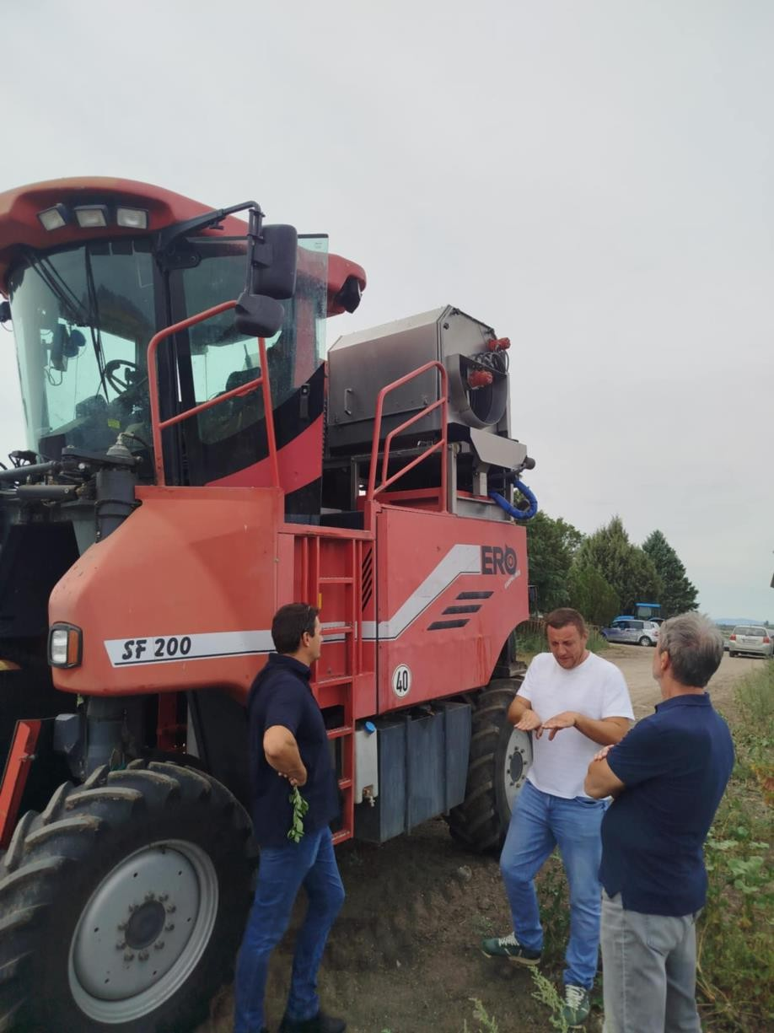
Image Training on environmental sustainability and technological progress

2. Digitalization in agriculture
Digitalization is the foundation of modern agriculture. It is the process of transforming agricultural processes into digital formats, which enables the collection, processing, and analysis of huge amounts of data. The main goal is to create a digital farm model, based on which informed decisions are made in real time.
Information technology (I О T) is a key driver of digitalization. Sensors in the ground, smart weather stations, and machine sensors collect data on humidity, temperature, nutrient levels, and equipment condition. All this data is sent to a central platform (the cloud), where it is analyzed using big data analytics and artificial intelligence ( AI ). These technologies recognize patterns, predict crop needs, and generate precise recommendations, such as when and how much water or fertilizer to add. For example, a system can automatically activate an irrigation pump as soon as sensors register that soil moisture has dropped below optimal levels.
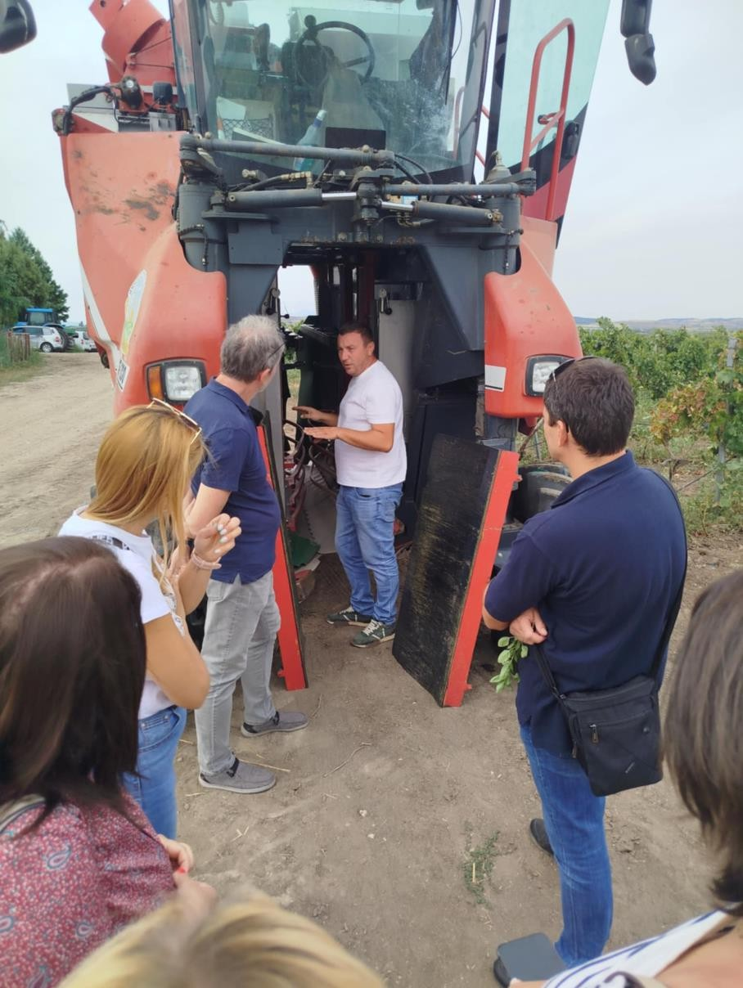
Image Training on environmental sustainability and technological progress

3. Use of drones in agriculture
Дронови (беспилотне летелице) постали су незаобилазно средство за даљинско праћење фарми. Брзи, прецизни и ефикасни, могу да обављају посао за који би људима биле потребне недеље. Опремљени су разним врстама камера и сензора.

- Мултиспектралне камере: Снимају слике у спектрима које људско око не може да види (инфрацрвено, ултраљубичасто), што омогућава рано откривање стреса биљака изазваног болестима, штеточинама, недостатком воде или хранљивих материја.
  - Thermal cameras: Measure leaf and soil temperatures, providing insight into drought stress. Stressed plants have higher temperatures.
• LiDAR sensors: Used to create detailed 3D topographic maps of the terrain, which is useful for planning irrigation, drainage, and land leveling systems.

Поред праћења, дронови се све више користе за прецизно прскање. Дронови опремљени прскалицама могу циљати само делове поља зараженог коровом, смањујући потрошњу пестицида и до 90% у поређењу са традиционалним прскањем.
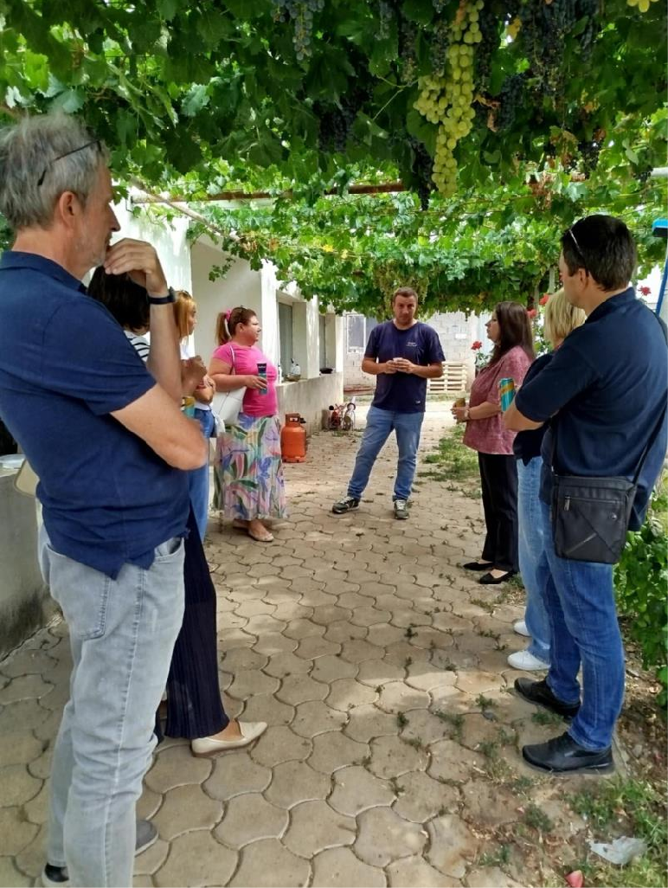

Image Training on environmental sustainability and technological progress

4. Automation and robotics
Automation and robotics are replacing difficult, repetitive, and dangerous farm jobs, increasing productivity and reducing manual labor .
  - Autonomous tractors and machines: Equipped with high-precision GPS (RTK-GPS) and sensors, these tractors can plow, sow and harvest autonomously , with an accuracy of just a few centimeters. This reduces overlap, saves fuel and seed, and allows for 24/7 operation, without fatigue.
  - Planting and harvesting robots: Specialized robots can recognize and precisely plant seedlings or harvest ripe fruits and vegetables. For example, strawberry picking robots are equipped with artificial intelligence systems that can recognize ripe fruit and harvest it without damage.
  - Weeding robots: Instead of spraying herbicides, small autonomous robots can physically remove weeds from crops, drastically reducing the use of chemicals and contributing to organic production.
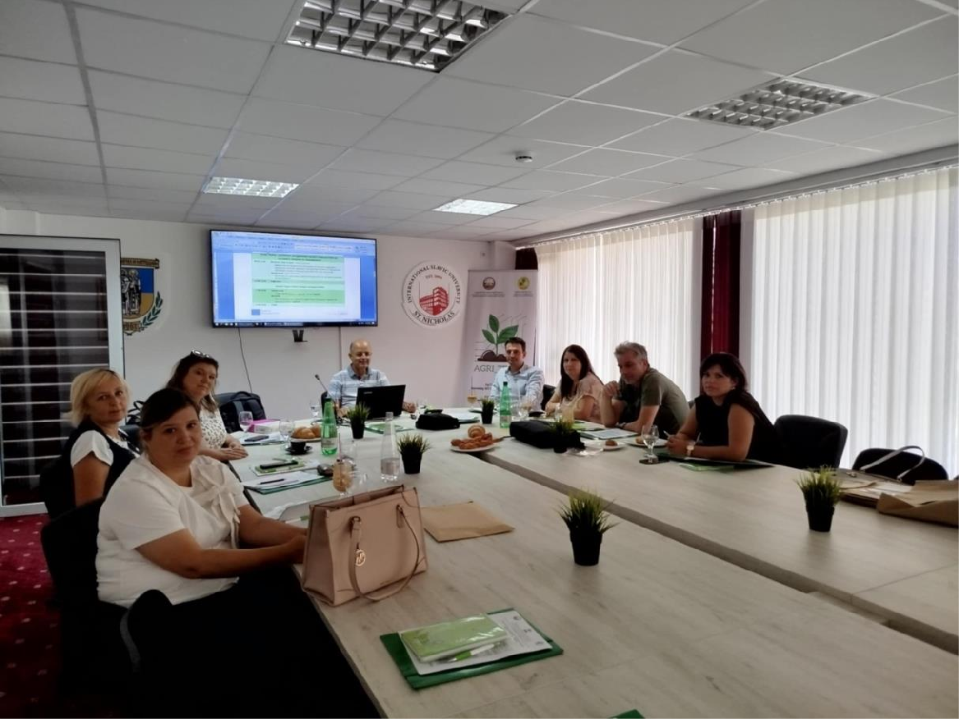
Image Training on environmental sustainability and technological progress

5. Precision agriculture
Precision agriculture is a philosophy of agricultural management that applies specific treatments based on the individual needs of each part of the plot.
  - Variable Fertilization: Instead of fertilizing the entire field with the same amount, sensors measure nitrogen, phosphorus, and potassium levels. A fertilizer map is then created and automatically uploaded to the spreader, which applies different amounts of fertilizer depending on the needs of each part of the field.
  - Smart irrigation: Soil moisture sensors send data to a central system that activates the irrigation system only in areas of the field where it is necessary. This saves water and energy and prevents over-irrigation, which can lead to crop failure.
  - Yield optimization: Combine harvesters equipped with yield sensors measure the amount of harvested crop in real time and create yield maps. Analyzing these maps allows farmers to identify problems in the field and improve their strategy for the next season.
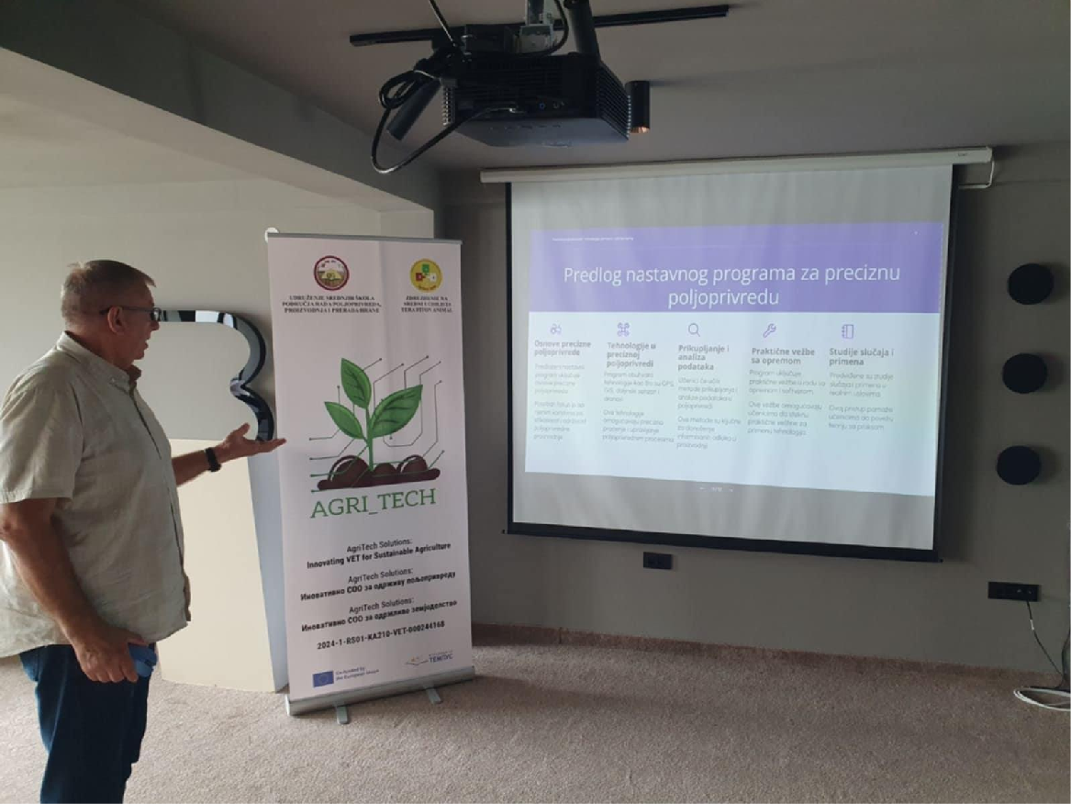
Image Training on environmental sustainability and technological progress

6. Sustainable agriculture and technologies
Modern technologies are key to achieving sustainability in agriculture. They enable more efficient use of resources and a reduction in the ecological footprint.
- Pollution reduction: Precise application of fertilizers and pesticides prevents pollution of groundwater, rivers and lakes. Fewer chemical inputs mean further improvement of soil quality and preservation of biodiversity.
  - Water savings: Smart irrigation systems save millions of liters of water annually.
  - Reducing CO₂ emissions: The use of autonomous machines, which optimize work and travel, reduces fuel consumption and gas emissions.

7. Challenges and obstacles in the application of technology
Despite its numerous advantages, the introduction of modern technology into agriculture is not without challenges.
High initial costs: Purchasing modern equipment and software is a significant investment, especially for small and medium-sized farms.
Digital literacy: Many farmers lack sufficient knowledge about digital tools and software.
Infrastructure: The lack of fast and stable internet connection in rural areas is a major obstacle to real-time data transmission.
Maintenance and technical support: Complex machines require specialized maintenance.

8. Conclusion​​​
Modern technologies are not only the future, but also the present of agriculture. They enable the transition to more efficient, profitable and, most importantly, sustainable agricultural production.
Although there are significant challenges in implementation, the role of education, government support, and technological advancements will help overcome obstacles, making these technologies accessible to a wider range of farmers.
The ultimate goal is to create an agriculture that is resilient to economic and environmental pressures, ensuring food supplies for future generations.

